 | ANGLO-CHINESE JUNIOR COLLEGE  JC2 Preliminary Examination  Higher 1

GEOGRAPHY |  | 8834/01
Paper 1 |  | 26 August 2024
Insert |  | 3 hours

READ THESE INSTRUCTIONS FIRST

This Insert contains all the Resources referred to in the questions.

This document consists of 8 printed pages.
Resource 1 for Question 1

Photographs of Bukit Merah Bus Interchange and Tiong Bahru Plaza shopping mall

Bukit Merah Bus Interchange

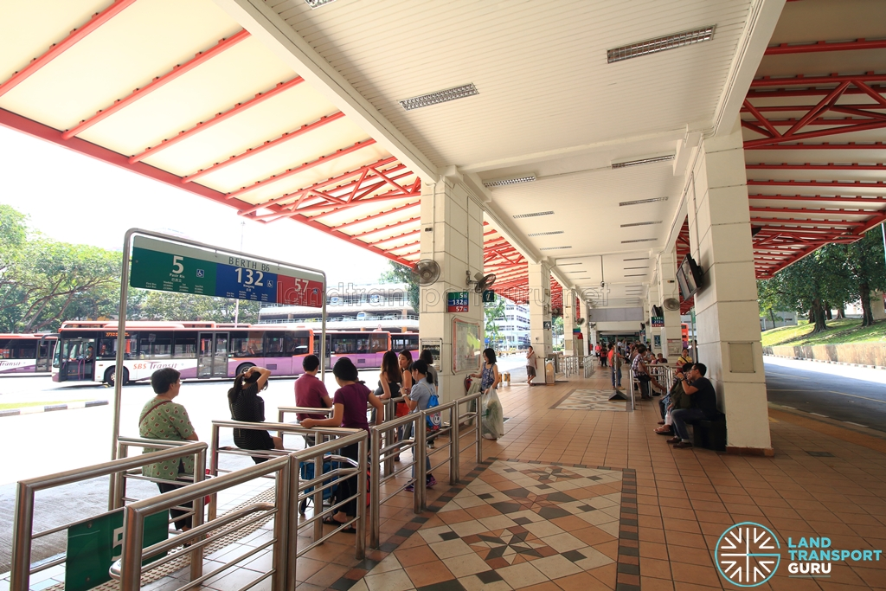

Tiong Bahru Plaza shopping mall

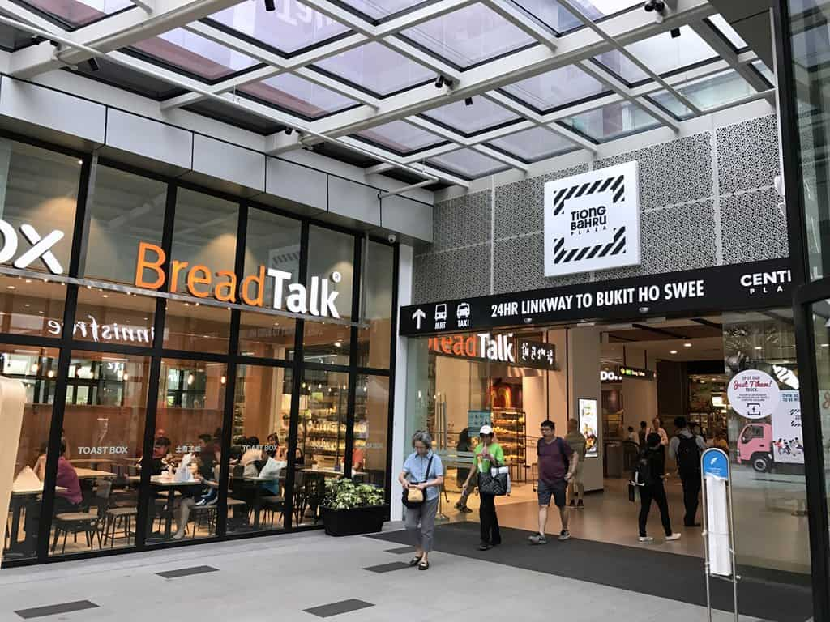

Resource 2 for Question 1

Survey

Question | Options
Age | 60–65 / 66–70 / 71–75 / 76–80 / 81+
Outdoor Spaces
Feel Safe in Outdoor Spaces | Yes / Sometimes / No
Accessibility of Outdoor Spaces | Yes / Sometimes / No
Quality of Footpaths | Yes / Sometimes / No
Enough Public Benches | Yes / Sometimes / No
Seating with Armrests and Backs | Yes / Sometimes / No
Ease of Going Outdoors for Walks or Errands | Yes / Sometimes / No
Multigenerational Activities Available | Yes / Sometimes / No
Public Transportation
Transport Options Available | Yes / Sometimes / No
Public Transport System Rating | Yes / Sometimes / No
Ease of Using Public Transport | Yes / Sometimes / No

Resource 3 for Question 1

Selected results of the survey

 | No (%) | Sometimes (%) | Yes (%)
Feel Safe in Outdoor Spaces | 13 | 17 | 70
Accessibility of Outdoor Spaces | 3 | 33 | 63
Quality of Footpaths | 13 | 40 | 47
Enough Public Benches | 17 | 17 | 67
Seating with Armrests and Backs | 13 | 23 | 63
Ease of Going Outdoors for Walks or Errands | 7 | 7 | 87
Multigenerational Activities Available | 20 | 37 | 43
Transport Options Available | 7 | 20 | 73
Public Transport System Rating | 23 | 30 | 47
Ease of Using Public Transport | 10 | 30 | 60

Resource 4 for Question 2

Temperature change since the mid-19th century

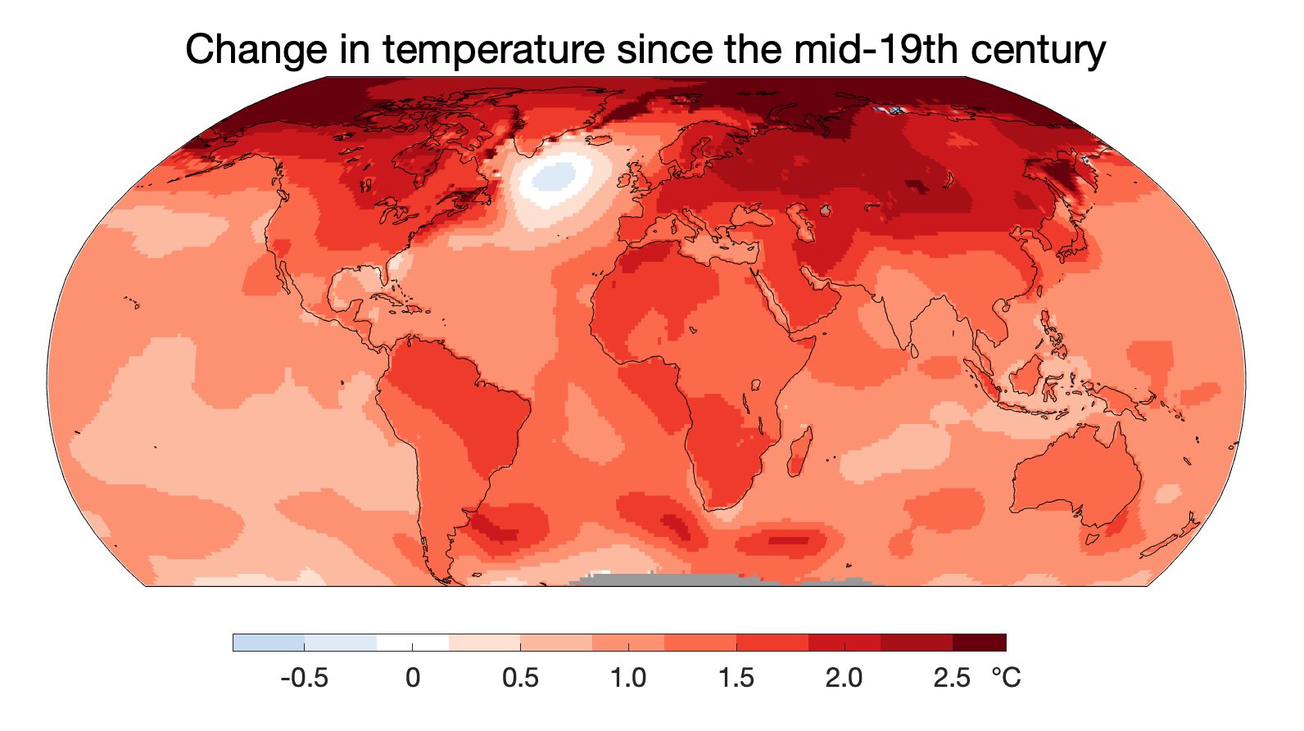

Resource 5 for Question 2

The 20 largest contributors to cumulative carbon dioxide (CO₂) emissions
from 1850 to 2021

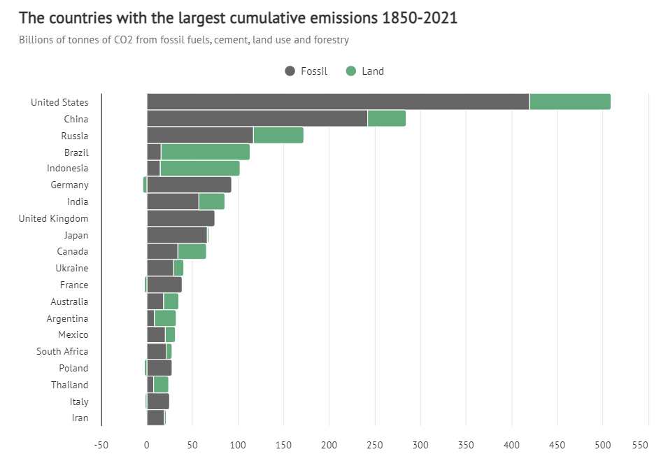
Billion tonnes
Resource 6 for Question 3

Photographs of London docklands in 1968 and 2018

1968

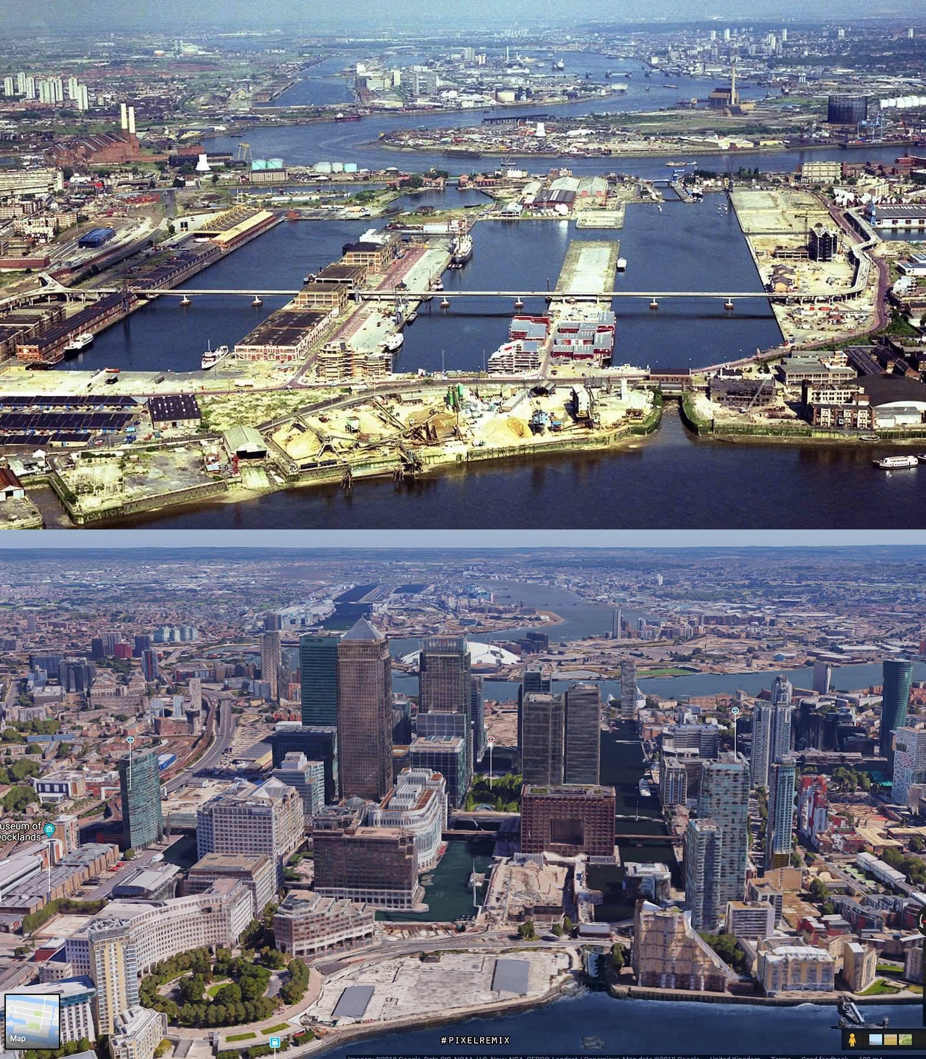

2018

Resource 7 for Question 3

Population changes in the London docklands towns from 1801 to 2019

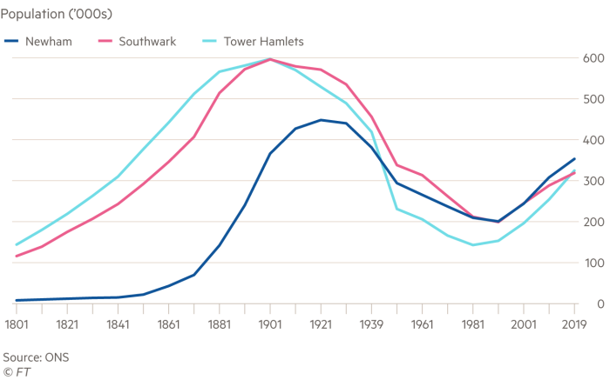

Resource 8 for Question 3

Article about Canary Wharf

Canary Wharf, once a neglected area of marshland and disused docklands, has become a leading global financial centre since the 1990s. Originally a "back office" for major financial institutions, it now houses the European headquarters of major corporations such as Barclays, HSBC, and JP Morgan, rivaling the City of London’s financial district, the "Square Mile."

The development of the Elizabeth Line (formerly known as Crossrail), nearing completion, is set to further boost Canary Wharf's appeal by adding 10% to London Underground’s capacity and significantly shortening travel times across the city. This follows earlier infrastructure projects like the Docklands Light Railway (DLR) and the Jubilee Line extension, which spurred growth in the 1990s and 2000s.

The new line has made Canary Wharf even more attractive for developments like Wood Wharf (a housing project in Canary Wharf) that brings 4,000 new homes, Europe’s largest bio lab, and a "green spine" created in partnership with the Eden Project.

